Impact of Bison reintroduction in Siberia

What is the optimal density of American bison to reintroduce in Siberia to slow down the thawing of the permafrost by trampling the snow?

We decided to choose a subject about ecological issues and we began by looking into species reintroduction impact on ecosystems. Species reintroduction goal is to try to rescue species from extinction and rehabilitate them into the habitat they used to live in.[1]

This subject interested us because we could look at the negative and positive impact on the surrounding ecosystem. After some research, a project caught our attention, Pleistocene Park.

Its goal is to reintroduce bison and other large herbivores in Siberia to considerably decelerate permafrost thawing which could potentially lead to slowing down global warming. Permafrost is any ground that remains completely frozen (at or below 0 °C) for at least two years in a row. In theory, the trampling of snow by large herbivores densifies the snow which creates an ice sheet that is harder to melt, allowing the soil temperature to stay at an appropriate level, therefore conserving the permafrost.[2] The permafrost represents 20% of the continental surface of the earth.[3] (cf Figure 1)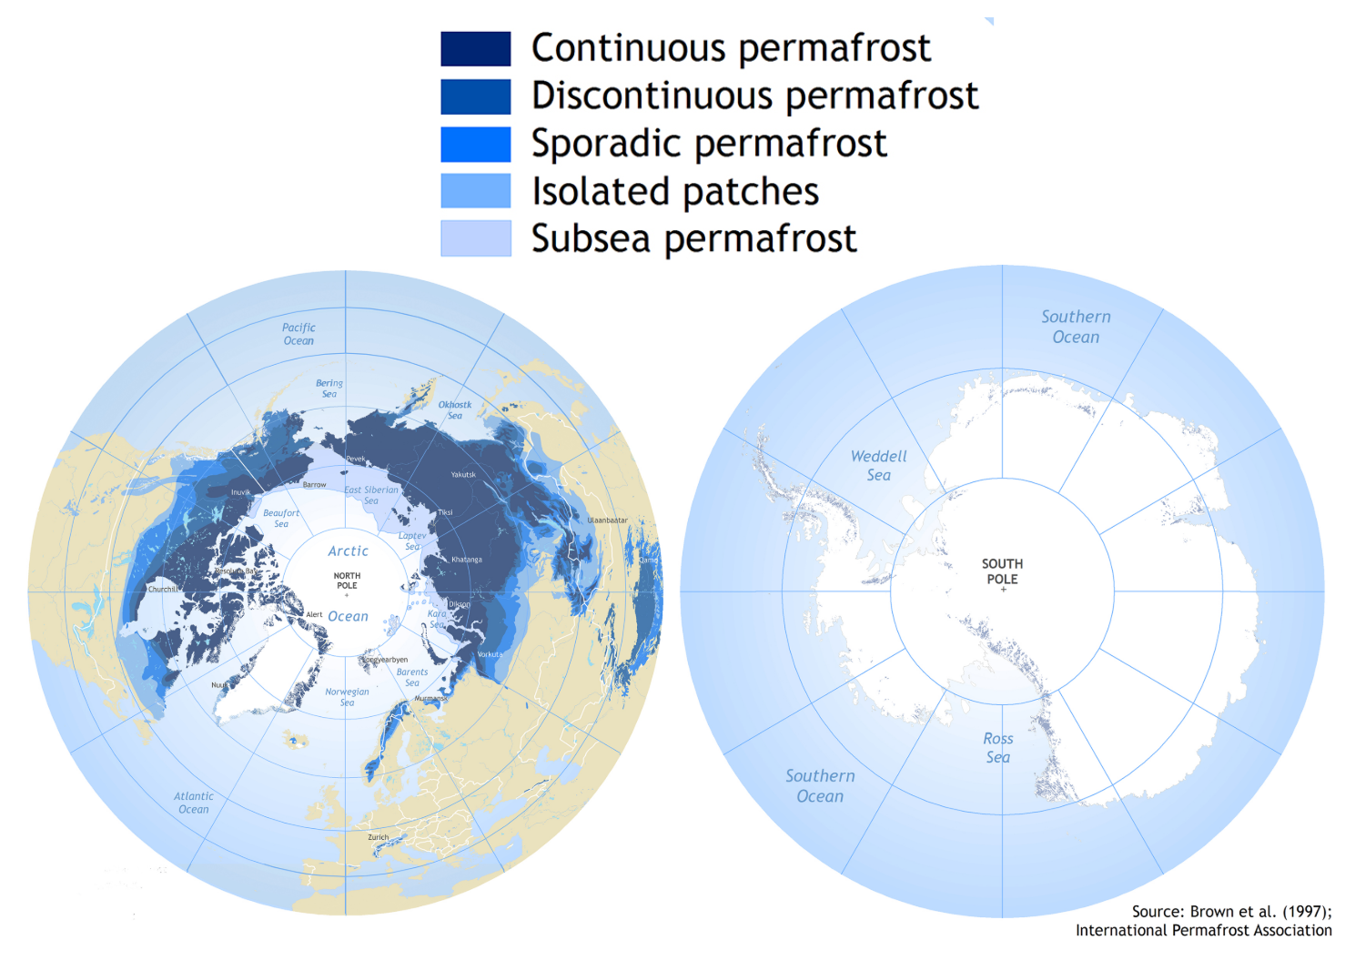

Figure 1 : Permafrost map

Rising temperatures due to global warming are causing snow to melt faster and the permafrost to disappear. Ice layers start to disappear, making the ocean level rise, and releasing greenhouse gases in the atmosphere like methane and CO2. These gasses were either trapped for millions of years in the ice and soil, either the consequence of bacterial development while the soil is warming.[4]

So keeping the permafrost will play in favor of mitigating global warming. In Pleistocene Park in Siberia, this hypothesis is being tested in order to research the climatic effects of the expected changes in the ecosystem. They're reinserting large herds of herbivores like buffalos, horses, elks, to re-create the northern subarctic steppe grassland ecosystem that flourished in the area during the last glacial period. Indeed, comparing the temperature of the soil in and outside the park, scientists found that increasing mammalian population density leads to a temperature decrease of about -1,9 °C in Pleistocene park.[5] (cf Figure 2)

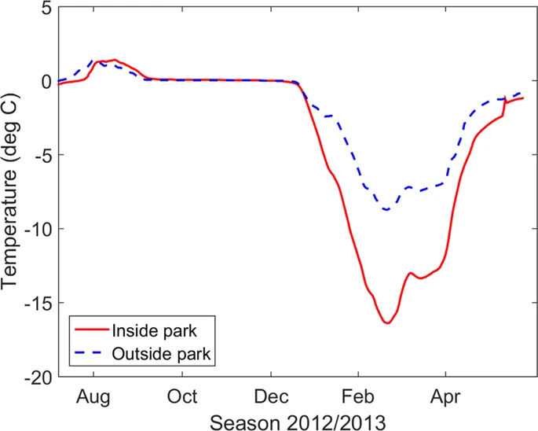

Figure 2: Evolution of soil temperature from August 2012 to April 2013

From Beer, Christian, et al. “Protection of Permafrost Soils from Thawing by Increasing Herbivore Density.”

So we asked ourselves what is the optimal density of American bison to reintroduce in Siberia to slow down the thawing of the permafrost by trampling the snow?

Our project is to model the stomping of a population of Plains Bison which scientific name is *Bison bison bison*, a subspecies of American Buffalo, and the effect of this trampling on the permafrost to understand the impact of the reintroduction of this species in Siberia. We will base our study on the Pleistocene Park ecosystem where noticeable changes have been observed after the introduction of large herbivores herds.

To build our model we started by **defining our variables and parameters**, we choose these variables to best represent what we’re trying to observe while simplifying it :

**Parameters**:

Parameters we used in the Temperature calculus : w = 2 * pi / 6 (6 months for a season) phi = 0 Bisons density (B) → fixed density that we change for different plots,

kAS : relation between the temperature of the air and the mass enthalpy of snow

kB : Impact of Bisons

kGS : impact of ground on snow

kAI : relation between the temperature of the air and the mass enthalpy of ice

kIG : value of thermal resistance of the ice stopping the temperature of the air

kSG : value of thermal resistance of the snow stopping the temperature of the air

kAG : thermic exchange between the air and the ground

**Variables :**

* Quantity of ice layer thickness in cm (I)
* Quantity of snow layer thickness in cm (S)
* Ground temperature (G) in Kelvin measured not too deep into the ground

**Input variables :**

Since this variable is independent (not influenced by other variables) and since we study its effects on the other variables, it’s our input variable.

* Air temperature (A) → sine function (2 seasons winter and summer) in kelvin.

**Output variables :**

We study the Ground temperature so it is our output variable.

And by **representing the different interactions between the variables of our system**:

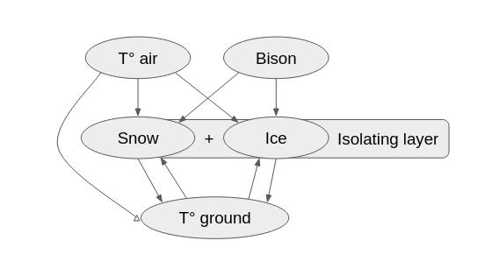

Figure 1 : Diagram of our system interconnections

* The temperature of the air influences the snow and the ice by melting them (S and I getting lower) when it gets too hot (A high), it influences the temperature of the ground by raising it (risk of loss of the permafrost state) when the insulating effects of the snow and ice are not enough to stop it (we don’t really take into account any impact of G on A because we consider the air temperature to be seasonal and not really fluctuating).
* The bisons cause something like a compartment model between snow and ice where

S → I.

* The snow and ice impact the ground by insulating it but later in the code we didn’t take into account the effects of the snow (it’s worth noting that the ice insulation is more effective than the snow’s, so we have : if I is high, G is lower ).
* The ground temperature impacts the snow and ice by melting them( if G is high )and by countering the effects of A (if A is high and G is low).

The next step was to write the **equations defining those interactions**:

**Air temperature:**

A = (20) * cos(w * t + phi) +264

With : w = 2pi/T, the +264 to be in the correct range (244 to 284 K) and the 20 for our amplitude.

**Bisons variation :**

B = constant (we first thought about making B a variable but ultimately decided against it. It was easier to just plot different graphic testing different density of bizons.)

We decided to use differential equations because they are a great model to describe phenomena, and predict their evolution.

For the following equations we decided to represent the different negative and positive effects:

**Snow variation :**

dSdt = -kAS * A * S - kGS * G *S - kB * B * S

(the snow melting possibly attenuated by the temperature of the ground and the snow being compacted )

We multiply the constant by the differents variables to keep proportions from going out of range

We multiply kAS by A to adjust the melting effects with the temperature and by S to take the same proportion but not the same quantity of snow for different quantities of snow, (the more snow there is, the more snow will melt) we multiply kGS and kB with G, S and B, S for the same reasons.

**Ice variation :**

dIdt = -kAI * A * I - kGI * G *S + kB * B * S

(the same interactions as the snow with different constants and the ice being created by the bisons)

The logic is the same as for the snow except that we multiply A by I and not S and we keep kB multiplied by S and not by I because it’s simply a transfer and has the same proportions.

(worth noting kAI < kAS → the snow melts faster than ice)

**Ground temperature variation :**

dGdt = kAG * (A-G) -kIG * I

(The warming effect of the air and the insulating effect of ice)

We decided not to use the insulating effect of the snow, we multiply kIG, which is the thermal resistance of ice, by I because more ice means more insulation.

We multiply kAG by (A-G) to take into account both the temperature of the ground and the temperature of the air. We assume that the ground temperature value has a tendency to go towards the value of air temperature with a certain delay. When we have G(t)>A(t) (the ground warmer than the air) then the overall value will be negative (⇒cool the ground), but if A(t)> G(t) the overall value will be positive (⇒warm the ground).

In a case where we would have an optimal density of bison, we expect the quantity of ice to be higher than in other cases and we expect for the temperature of the ground to be lower in general which would mean that the permafrost is preserved.

**Initial values:**

We need

G(t=0) = 274 K (ground temperature)

I(t=0) Quantity of ice at t=0

S(t=0) Quantity of snow at t=0 (supposed to be higher than I(t=0))

B Quantity of bisons in the simulation

We started writing the code while defining our initial values and giving numerical values to our parameters, which means that we struggled to make everything work since we wanted to use

realistic and accurate values from the beginning (we also changed our differential equations that have been updated on the previous pages).

We obtained those graphs :

with 0 bisons

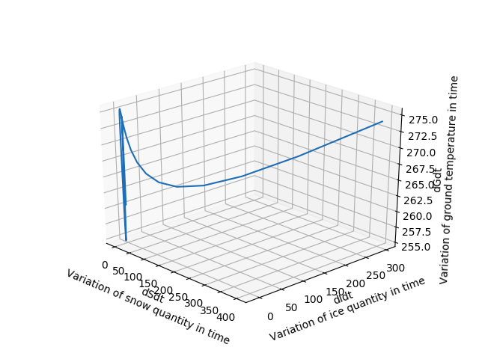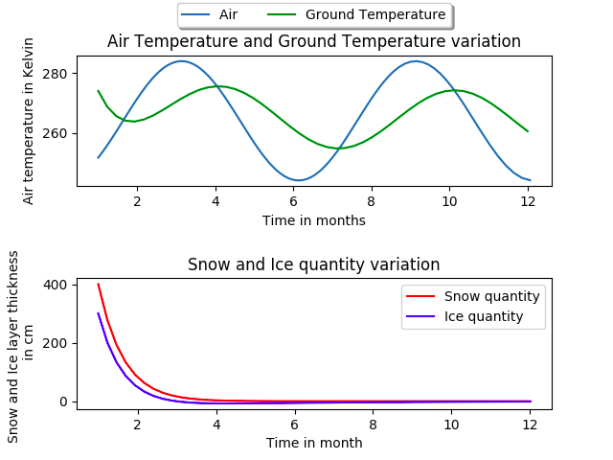

And with 20 bisons

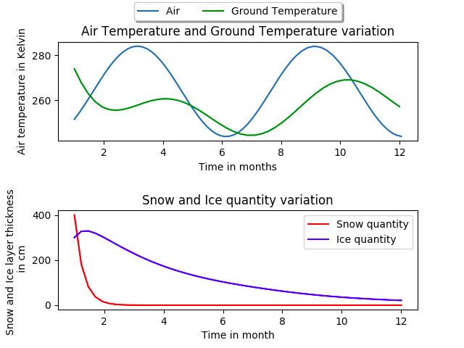

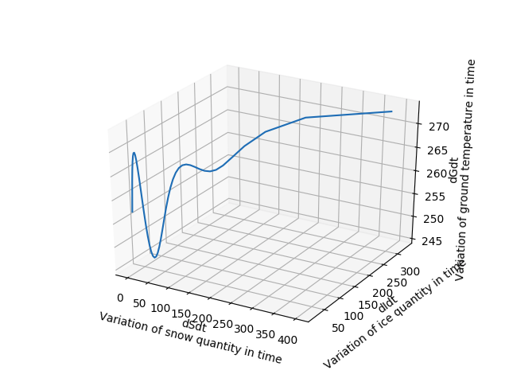

We can see the effects of bisons being present, the quantity of snow drops quicker, the quantity of ice grows and the overall ground temperature is lower. Even when the temperature is getting hotter it stays below 0°C (274,15 K).This supports the hypothesis that the introduction of bisons would preserve the permafrost.

**Details on the parameters (their effects and weight):**

kB : When we give kB a too high value all the snow disappears very quickly and G has globally a lower temperature.

When we give kB a very low value the ice behaves almost as if there’s no bison and G globally is higher. So the higher the value the quicker the transition from snow to ice and the higher the effect of ice on G.

B: we observe the same variations for B that we did with kB

**Strong points and limitations of our model:**

**Strong points:**

The model works with the information we found about how large herbivores could compact the snow to better isolate the ground and preserve the permafrost.

**Limitations:**

In the end we added the bison density as a constant but at first we wanted to set it as an input variable in order to observe the effects of a more realistic population. In fact we cannot see the effect the variations of the population could have on the ground temperature.

Quantity of snow is always decreasing, which is the biggest weakness of our system. We decided to only lower the quantity of snow when the temperature is high, without taking in account that this is supposed to increase in winter.

To simplify we just admitted that bisons create the ice by walking on the snow (and so reducing the quantity of snow) and this could be debated, in reality it’s more of an increase in density.

We generally missed a lot of interactions or we oversimplified them.

Doing this model we asked ourselves what was the optimal density of bisons to reintroduce but becauses of our limitations we haven’t been able to fully answer this question.

**Perspectives:**

We could have added snowfall in function of the season, which would make our model more realistic and make it run for longer (for now after you reach a certain point all of the snow disappears).

We could have added greenhouse gases as a variable to represent how the melting of the permafrost causes the air to heat up (positive feedback loop).

We did a lot of research on the constants and the physics that go into the relations between the variables but had a lot of difficulties implanting them into the code, using these values to define the model would give us a much more accurate and realistic model.

We could have extended this model implementing other variables which represent the surrounding ecosystem, with a bison population that changes over time. That would be a way to see the impact as a bigger of bison reintroduction both negative and positive.

1. Sarrazin, Frangois, and Robert Barbault. “Reintroduction: Challenges and Lessons for Basic Ecology.” *Trends in Ecology & Evolution*, vol. 11, no. 11, Nov. 1996, pp. 474–78, doi:10.1016/0169-5347(96)20092-8.
2. Peters, Adele, et al. “Baby Bison Are Being Flown To Siberia To Try To Save The Permafrost.” *Fast Company*, 23 Apr. 2018, https://www.fastcompany.com/40561843/baby-bison-are-being-flow-to-siberia-to-try-to-save-the-permafrost.
3. “Le permafrost.” *Encyclopédie de l’environnement*, 21 Oct. 2016, https://www.encyclopedie-environnement.org/sol/le-permafrost/.
4. Schuur, E. a. G., et al. “Climate Change and the Permafrost Carbon Feedback.” *Nature*, vol. 520, no. 7546, Apr. 2015, pp. 171–79, doi:10.1038/nature14338.
5. Beer, Christian, et al. “Protection of Permafrost Soils from Thawing by Increasing Herbivore Density.” *Scientific Reports*, vol. 10, no. 1, Mar. 2020, pp. 1–10, doi:10.1038/s41598-020-60938-y.